**Project Title**

**J.A.R.V.I.S. like**

**Desktop Voice Assistant**

**(DVA)**



**PROJECT REPORT ON**

**JARVIS like Desktop Voice Assistant**

**UNDER THE GUIDANCE OF**

**Ms.**

**SUBMITTED BY**

**SEGURO JC**

**UNIVERSITY OF MUMBAI**

**T.Y.B.Sc (COMPUTER SCIENCE)**

**ACADEMIC YEAR: 2020-2021**



**BHARTIYA VIDYA BHAVAN’S**

**MM COLLEGE OF ARTS, NM COLLEGE OF COMMERCE &**

**HRJ COLLEGE OF COMMERCE**

**BHAVAN’S COLLEGE**

**MUNSHI NAGAR, ANDHERI (WEST),**

**MUMBAI – 400058**



**BHARTIYA VIDYA BHAVAN’S**

**MM COLLEGE OF ARTS, NM COLLEGE OF COMMERCE**

**& HRJ COLLEGE OF COMMERCE**

**BHAVAN’S COLLEGE MUNSHI NAGAR, ANDHERI**

**(WEST), MUMBAI – 400058**

BHARATIYA VIDYA BHAVAN

# BHAVAN’S COLLEGE, ANDHERI (W)

**CERTIFICATE**

This is to certify that **Mr.SEGURO JC, Roll No. TYCS**  **of T. Y. B. Sc. Computer Science** has satisfactorily completed the practical course in **Project Implementation** as prescribed by the University of Mumbai during the academic year **2020-2021.**

Signature Signature

**Project Guide Coordinator**

Signature

**External Examiner** **College Stamp**

**ACKNOWLEDGEMENT**

I would like to express my sincere gratitude towards the Computer Science Department of Bhavan’s College.

After months of hard work, finally I am very happy to present my final year Project. The Project making was full of new experiences and learning and difficult one too. Though a difficult job it was made simpler by the timely guidance received, which helped me greatly in the completion of my project. But it wouldn’t be right to do so without thanking to those who have helped me in converting our thought into reality. So I would like to take full advantage of this opportunity to thank each and every person who has helped me throughout the completion of our project.

I am obliged to my parents & family members who always support me greatly and encouraged me in each and every step. I would also like to thank my classmates who helped me to complete my project

They have been instrumental for making me concentrate and focus my effort in this project.

Finally, I would like to thank each and every individual who was directly or indirectly contributing for this project.

**-Thank you.**

**TYCS SEM-VI PROJECT INDEX**

|  |  |  |  |
| --- | --- | --- | --- |
| **Sr. No.** | **Topic** | **Page no.** | **Sign & Remark** |
| **1** | **Abstract and keywords** | **6** |  |
|  |  |  |  |
| **2** | **Introduction** | **7-8** |  |
| 2.1 | Problem Statement | 7 |  |
| 2.2 | Literature Review/Description of Present System | 7 |  |
| 2.3 | Background /Limitations | 8 |  |
| 2.4 | Aim & Objectives | 8 |  |
| 2.5 | Project Motivation | 8 |  |
|  |  |  |  |
| **3** | **Description of Proposed Work** | **9-12** |  |
| 3.1 | Number of Modules | 9 |  |
| 3.2 | Algorithm | 9 |  |
| 3.3 | Working | 10 |  |
| 3.4 | Design/Block diagram/flow chart/graph/deployment diagram/Architectural Design | 11 |  |
| 3.5 | Screen Layouts | 12 |  |
|  |  |  |  |
| **4** | **Technology/Language/Development Tools/Hardware** | **13** |  |
|  |  |  |  |
| **5** | **Conclusion & Future Scope** | **13** |  |
|  |  |  |  |
| **6** | **References/Resource Material/Data collection** | **14** |  |
|  |  |  |  |
| **7** | **Plagiarism Report** | **14** |  |

1. **Abstract and keywords**
   1. **Abstract :**

* The project aims to develop a desktop voice assistant for Windows-based systems. Jarvis draws its inspiration from virtual assistants like Cortana for Windows, and Siri for iOS. It has been designed to provide a user-friendly interface for carrying out a variety of tasks by employing certain well-defined commands.
* The Desktop voice assistant who helps the end user to communicate with desktop computer with voice and it also responds to the voice commands of the user.
* Our Proposed System has capability to work with and without Internet Connectivity in desktop computer.
* It is named as JARVIS like Desktop voice Assistant with Voice Recognition Intelligence, which takes the user input in form of voice and process it and returns the output in various forms like action to be performed or the search result is dictated to the end user
  1. **Keyword :**
* DVA (Desktop Voice Assistant)
* Python script
* speech recognition
* sapi5 (speech API)
* smtplib (sendEmail)

1. **Introduction**
   1. **Problem Statement :**

* We are all well aware about Cortana, Siri, Google Assistant and many other virtual assistants which are designed to aid the tasks of users in Windows, Android and iOS platforms.
* But there is no such an assistant available which UI is look like an Fictional AI J.A.R.V.I.S. (Just A Rather Very Intelligent System) and work as a voice assistant to do our task like sending emails, play music and google search, etc.
* It is also time consumes to mail by typing text, so the desktop voice assistant did our work easier we only need to do is to give speech command so the speech can be converts into text form.
* It is very helpful for people like those don’t want to search music player on start menu and play a song. It’s simply takes our voice command and open application like music player, google, and some other apps, etc.
  1. **Literature Review / Description of Present System :**
* A takeCommand() takes as input and produces an audio stream as output. A speak() on the other hand does opposite. It takes an audio stream as input and thus turns it into text transcription. The voice is a signal of infinite information.
* A direct analysis and synthesizing the complex voice signal is due to too much information contained in the signal. Therefore, the digital signal processes such as Feature Extraction and Feature Matching are introduced to represent the voice signal.
* In this project we directly use takeCommand() which use Feature extraction technique. Our aim to create more and more functionalities which can help human to assist in their daily life and also reduces their efforts. Design of a compact large vocabulary speech recognition system that can run efficiently on any laptop devices, accurately and with low latency.
  1. **Background / Limitation :**
* The devices which use the human voice for interacting with the device use single commands as input for the device they usually consist of single phrases. When commands become ambiguous, the resulting actions can be misunderstood by the devices.
* There is only one-way communication between the user and the device because the device cannot talk back for clarification. The applications on the devices cannot reply back with the state of the process whether it is ongoing or completed.
* They can not log any history about the queries made but they can be trained to learn about the user behavior and learn about the user’s usage statistics and give a recommendation to the user according to the time, place, or by any other calculated parameters.
  1. **Aim & Objectives :**

**Aim :** The Aim of Desktop Voice assistants can send email, look things up online, open apps, play songs and initiate or complete many other tasks. With the addition of separate voice option like male / female voice.

**Objective :** A Desktop voice assistant is a digital assistant that uses voice recognition, language processing algorithms, and voice synthesis to listen to specific voice commands and return relevant information or perform specific functions as requested by the user.

* 1. **Project Motivation :**
* The idea to make **J.A.R.V.I.S.** (Just A Rather Very Intelligent System) is a fictional artificial intelligence that first appeared on Marvel Comics And Iron Man Movie was the initial fictional concept.
* Later on it was decided to develop for windows to performs your day by day task with minimum efforts. So, Jarvis like Desktop Voice Assistant is to make life easier and perform some task using voice recognization and have some fun.

1. **Description of Proposed Work:**
   1. **Number of Modules:**
2. **Text-to-Speech : Pyttsx3**,This module is used for conversion of text to speech in a program it works offline.
3. **speechRecognition :** Since we’re building an Application of voice assistant, one of the most important things in this is that your assistant recognizes your voice (means what you want to say/ ask).
4. **Backend work :** At backend the python gets the output from speech recognition and after that it identifies whether the command is a system command or a browser command. The output is send back to python backend to give desired output to user.
   1. **Algorithm / Code :**

* **Code for recongnizing voice :**

import pyttsx3

engine = pyttsx3.init('sapi5')

voices= engine.getProperty('voices') #getting details of current voice

engine.setProperty('voice', voice[0].id)

* **Code for speaking function :**

def speak(audio):

engine.say(audio)

engine.runAndWait() #Without this command, speech will not be audible to us.

* **Code for command from voice function :**

def takeCommand():

#It takes microphone input from the user and returns string output

r = sr.Recognizer()

with sr.Microphone() as source:

print("Listening...")

r.pause_threshold = 1

audio = r.listen(source)

* **Code for opening wiki, youtube, google in browser :**

if __name__ == "__main__":

wishMe()

while True:

# if 1:

query = takeCommand().lower() #Converting user query into lower case

# Logic for executing tasks based on query

if 'wikipedia' in query: #if wikipedia found in the query then this block will be executed

speak('Searching Wikipedia...')

query = query.replace("wikipedia", "")

results = wikipedia.summary(query, sentences=2)

speak("According to Wikipedia")

print(results)

speak(results)

elif 'open youtube' in query:

webbrowser.open("youtube.com")

elif 'open google' in query:

webbrowser.open("google.com")

* 1. **Working :**
* First open the project folder then create virtual environment and run requirements.bat file to install python libraries after ‘run.py’ file.
* It will show a GUI interface of JARVIS like Desktop Voice Assistant. And it also show “Listening…” text in command line interface. This indicates that it is active.
* After Giving voice command, it will show as “Recognizing…” in command line interface. This means your query has been taken by voice assistant.
* After that it will print the text of your voice command in command-line interface.
* So basically, what you need to do is give a voice command. It simply converts your voice into text form and searches for results according to your query voice command.
* Results are like Opening YouTube, Opening Google, Opening VS code, Opening Music & videos, Play Music, Searching various results in google, shutdown PC, Restart PC, Minimizing DVA window etc.
* If you said something which is not available in query, the assistant will ask ‘Do you need to search on internet?’ If you reply Yes it will redirect to google and it give you the best result.
* The GUI windows has various onclick function for boot, reboot, close ,exit and it also shows Today’s date.
  1. **Flowchart Diagram :**

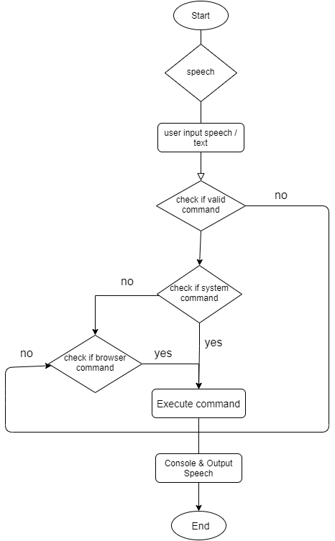

* 1. **Screen Layouts :**

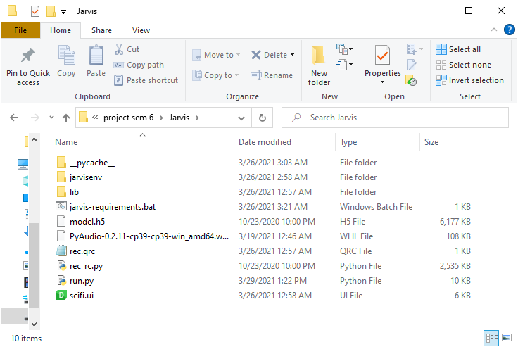

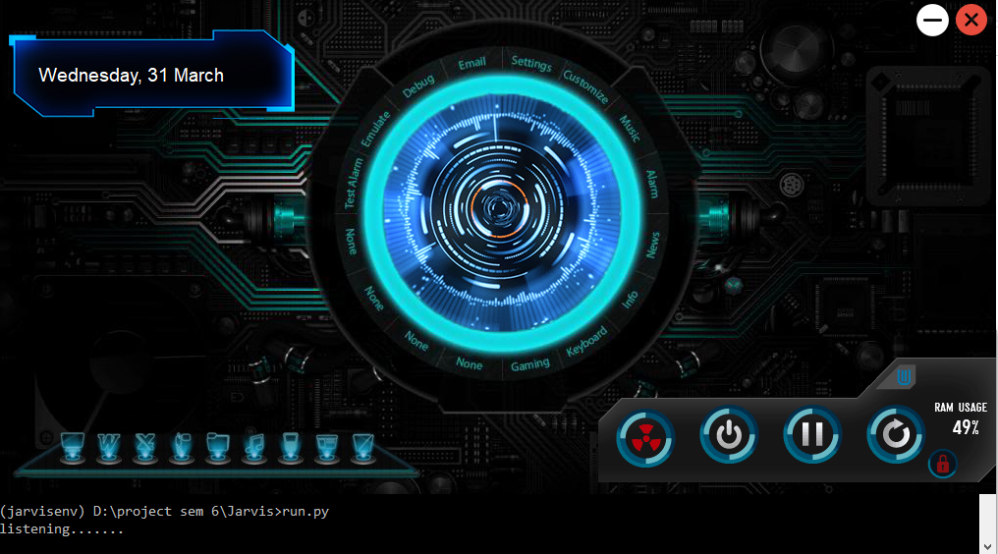

**4.Technology**

1. **Front End :**

* PyQt5 , Qt Designer and Visual Studio Code IDE

1. **Back End :**

* Python

1. **Software Requirement:**

* Python IDLE 3.9.2
* Visual Studio Code

1. **Hardware Requirement :**

* Windows 10
* Minimum 4GB RAM
* 2GB of available hard disk
* Intel Pentium Core 2 Duo or i3 processor or equivalent or higher

**5.Conclusion & Future Scope**

Desktop Voice Assistant is Designed to help Native and especially for Blind persons which works on their Voice Commands. DVA also has the capability of recognizing the voice commands without internet connection. DVA has various functionalities of Laptop devices like voice command and managing various applications on just the voice commands.

The future of voice assistants can be parameterize on an array of dimensions. With respect to compatibility and integration with other devices and systems, there i sill a lot to be achieved, Another dimension would be with respect to the redundant use of wake words at the beginning of each command. The individuality of results also poses a big problems. But for all intents and purposes, the future of these technology is a bright one. With advances in it and in technologies related to it (search processes, for example) Voice assistants can carry out even more complex tasks like booking tickets, etc.

**6.References**

1. [www.github.com](http://www.github.com)
2. [www.youtube.com](http://www.youtube.com)
3. [www.stackoverflow.com](http://www.stackoverflow.com)
4. [www.codewithharry.com/](http://www.codewithharry.com/)
5. [www.geeksforgeeks.org/](http://www.geeksforgeeks.org/)
6. [www.ijrte.org/](http://www.ijrte.org/)

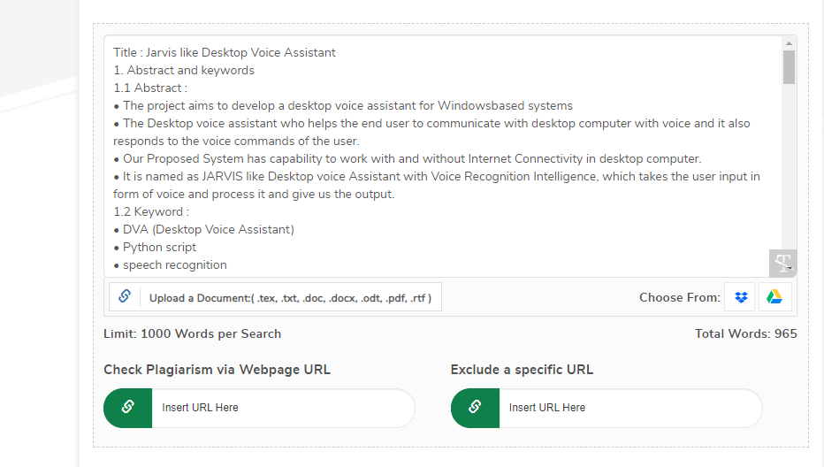**7.Plagiarism Report**

